Halloween Menu

Witches Finger

Jumping Jack Beans

Broomstick Fries

Chocolate Brownies

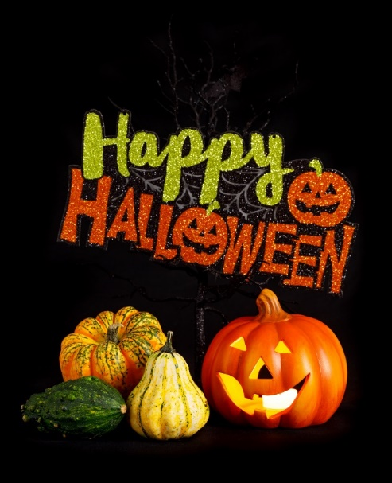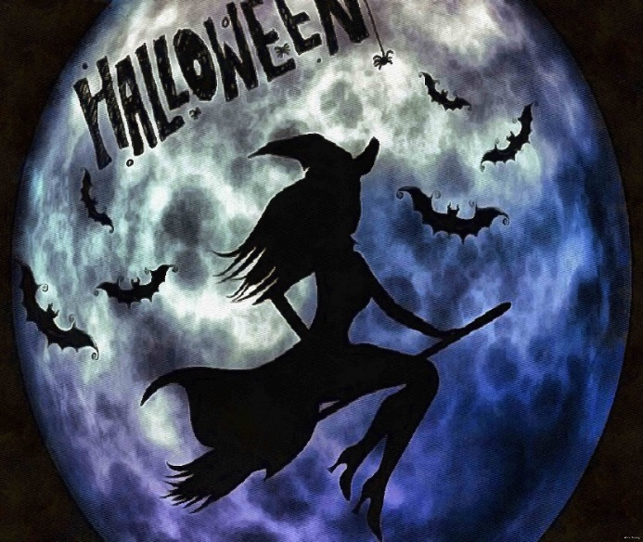Vampire’s Brew