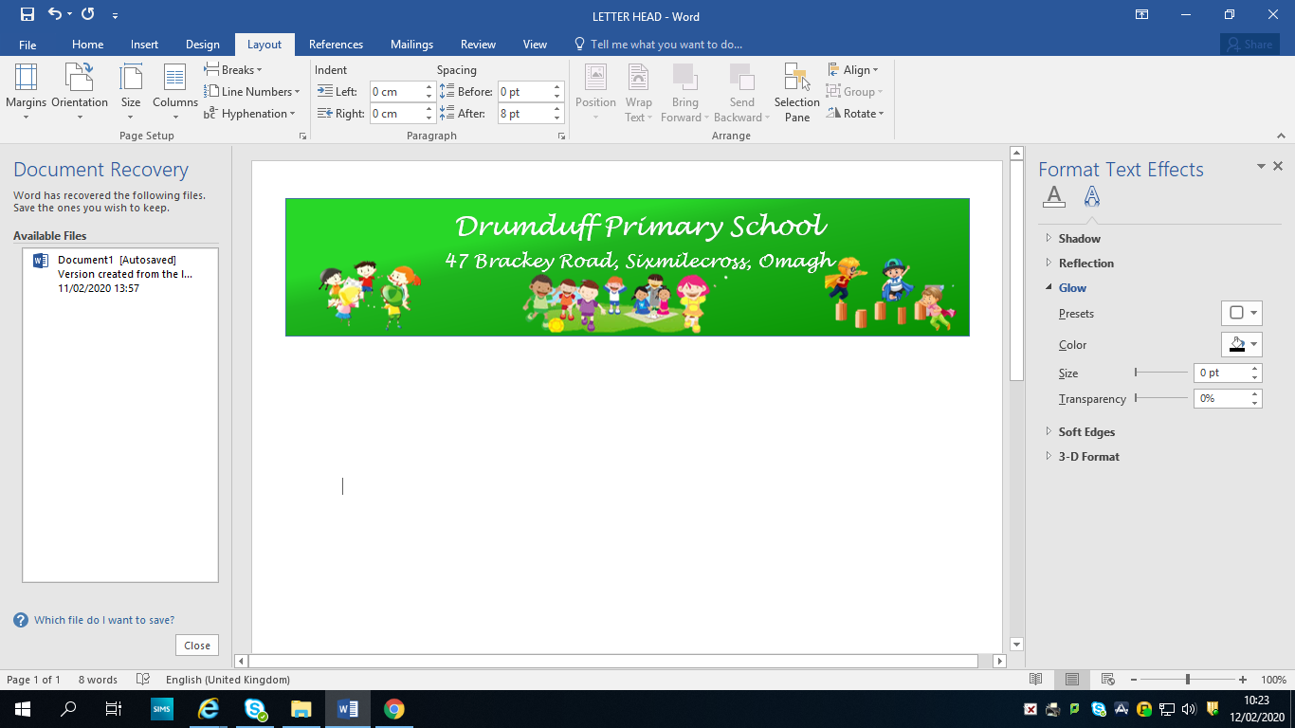**DRUMDUFF PRIMARY SCHOOL HOLIDAY LIST 2022 – 2023**

**29th – 31st August 2022** – Staff Training

**1st September 2022** – P.1. – P.7. return to school -Term 1 begins

**3rd October 2022** – School closed to pupils (Staff Development Day)

**28th October – 1st November 2022** – Halloween Holidays

**(Pupils return 2/11/22)**

**2nd December 2022 -** School closed to pupils (Staff Development Day)

**26th December 2022 – 6thth January 2023** – Christmas Holidays

**(School closes 23/12/22 @ 12 noon and pupils return 6/01/23)**

**13th – 17th February 2023** – Mid Term Break

**17th March 2023** – St. Patrick’s Day

**6th April – 14th April 2023** – Easter Holidays

**(School closes 5/04/23 @ 12 noon and pupils return 17/04/23)**

**1st May 2023** – Bank Holiday – School Closed

**29th May – 2nd June 2023** – School Closed **(Pupils return 05/06/23)**

**29th June 2023** – School closes @12 noon

**30th June 2023** – School Training

**\*This holiday list may be subject to change.\***