Halloween Menu

Witches Finger Log

Jumping Jack Beans

Broomstick Fries

Spooky Shortbread

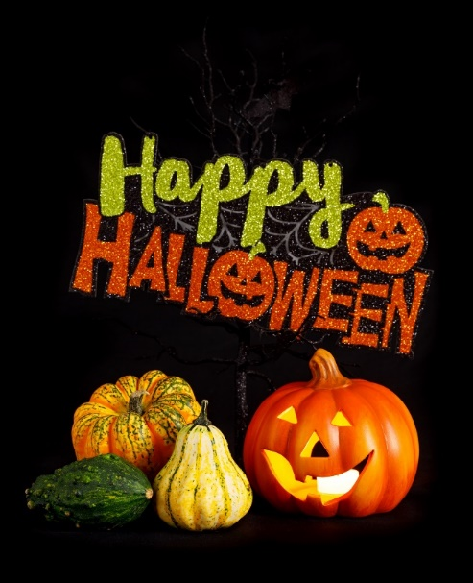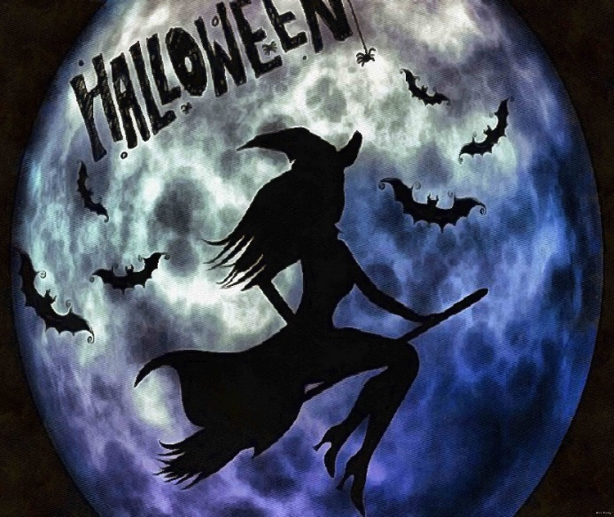Vampire’s Brew